Optimizing Student Database Management System for Enhanced Efficiency

A CAPSTONE PROJECT REPORT

# (Object Oriented Programming with C++ using Encapsulation-DSA0199)

***Submitted to***

**SAVEETHA INSTITUTE OF MEDICAL AND TECHNICAL SCIENCES**

***In partial fulfillment for the award of the degree of***

**BACHELOR OF ENGINEERING IN COMPUTER SCIENCE & ENGINEERING**

***By***

**U. Gnana Deepika (192210133)**

**P. Nikitha (192224194)**

***Course Faculty***

**Ms.S.Jayanthi**



**SAVEETHA SCHOOL OF ENGINEERING, SIMATS, CHENNAI - 602105**

**September-2024**

**SAVEETHA SCHOOL OF ENGINEERING**

**SAVEETHA INSTITUE OF MEDICAL AND TECHNICAL SCIENCES,CHENNAI - 602105**

**BONAFIDE CERTIFICATE**

Certified that this project report **“OPTIMIZING STUDENT DATABASE MANAGEMENT SYSTEM FOR ENHANCED EFFICIENCY”** is the Bonafide work of **“U.Gnana Deepika,P.Nikitha”** who carried out the project work under my supervision.

**Submitted to**

**Ms.S.Jayanthi**

(Course Faculty)

Department of Information Security, Saveetha School of Engineering, SIMATS

## SIGNATURE of Course Faculty

**ACKNOWLEDGEMENT**

This project work would not have been possible without the contribution of many people. It gives me immense pleasure to express my profound gratitude to our Honorable Chancellor **Dr. N. M. Veeraiyan**, Saveetha Institute of Medical and Technical Sciences, for his blessings and for being a source of inspiration. I sincerely thank our Director of Academics **Dr. Deepak Nallaswamy,** SIMATS, for his visionary thoughts and support. I am indebted to extend my gratitude to our Director **Dr. Ramya Deepak,** Saveetha School of Engineering, for facilitating us all the facilities and extended support to gain valuable education and learning experience.

I register my special thanks to **Dr. B. Ramesh,** Principal, Saveetha School of Engineering for the support given to me in the successful conduct of this project. I wish to express my sincere gratitude to my Course faculty **Ms.S.Jayanthi**, for his inspiring guidance, personal involvement and constant encouragement during the entire course of this work.

I am grateful to Project Coordinators, Review Panel External and Internal Members and the entire faculty of the Department of Design, for their constructive criticisms and valuable suggestions which have been a rich source to improve the quality of this work.

**STUDENT NAME’s**

**U.Gnana Deepika (192210133)**

**P.Nikitha(192224194)**

**TABLE OF CONTENTS**

|  |  |
| --- | --- |
| **CHAPTER**  **NO** | **TITLE** |
| **1** | **AIM** |
| **2** | **INTRODUCTION** |
| **3** | **PROBLEM STATEMENT** |
| **4** | **ERXPLANATION** |
| **5** | **CODE** |
| **6** | **RESULT** |
| **7** | **CONCLUSION** |

**AIM**

The Student Base Management System is a streamlined software solution designed to manage student information efficiently. This system facilitates the addition, display, modification, and deletion of student records. Developed using C++, the program leverages simple data structures to offer an intuitive interface for managing a student database, making it particularly suitable for small-scale educational institutions.

**INTRODUCTION**

Managing student information efficiently is a cornerstone of effective educational administration. With the growing number of students and the increasing complexity of academic programs, traditional paper-based record-keeping systems have become outdated. These systems are not only cumbersome but also prone to errors, data loss, and inefficiency. Educational institutions, ranging from small schools to large universities, face the challenge of maintaining accurate and accessible records for each student. This includes personal details, academic performance, and course enrolments.

The transition to digital systems offers a promising solution to these challenges. Digital student management systems streamline the process of handling student data, ensuring that information is easily accessible, accurate, and secure. However, many existing digital solutions are often expensive, complex, and not tailored to the needs of smaller institutions. This creates a significant gap in the market for a simple, cost-effective, and user-friendly student management system.

The Student Base Management System is designed to fill this gap. Developed using C++, a powerful and versatile programming language, this system provides essential functionalities needed to manage student information. It includes features for adding new student records, displaying existing records, modifying details of existing students, and deleting records that are no longer needed. The system employs basic data structures and input/output operations to create an intuitive interface that can be easily used by administrative staff with minimal training.

The proposed system is especially beneficial for small to medium-sized educational institutions that require an efficient way to manage their student records without investing in expensive and complex software solutions. The simplicity and effectiveness of the Student Base Management System make it an ideal choice for institutions looking to modernize their administrative processes.

**PROBLEM STATEMENT**

The goal is to enhance the efficiency of a Student Database Management System (SDMS) by optimizing data storage, retrieval, and processing mechanisms. The current system faces challenges in handling large volumes of data, leading to slow query responses and difficulty in maintaining data integrity. Key objectives include implementing advanced indexing techniques, optimizing query execution plans, and ensuring seamless scalability. Additionally, the project aims to integrate real-time data analytics and improve the user interface for better accessibility and user experience. The optimization should result in reduced latency, improved system reliability, and a streamlined process for academic and administrative tasks.

**EXPLANATION**

Many educational institutions still rely on manual record-keeping systems, which are inefficient and error-prone. Some have transitioned to more sophisticated software solutions, but these are often expensive and complex, making them inaccessible to smaller institutions. Existing digital systems may also suffer from issues such as poor user interfaces, lack of flexibility, and difficulty in managing updates and modifications.

**Proposed System**

The proposed Student Base Management System aims to address these challenges by providing a simple, cost-effective, and user-friendly solution. Key features of the system include:

1. **Add Student**: Allows users to input new student records.
2. **Display Students**: Displays all stored student records in a readable format.
3. **Modify Student**: Enables users to update the details of existing students.
4. **Delete Student**: Allows for the removal of student records from the system.
5. **User-Friendly Menu**: Provides an intuitive interface for easy navigation and operation.
6. **Optimizing**: This indicates the primary focus of the project, which is to make the SDMS more efficient by improving various aspects of its operation. Optimization involves identifying bottlenecks, reducing resource consumption, and enhancing overall performance.
7. **Student Database Management System (SDMS)**: This refers to the software system that manages student data. It includes functionalities like storing student records, processing academic information, handling administrative tasks, and providing data access to different users.
8. **Enhanced Efficiency**: This highlights the intended outcome of the optimization efforts. Enhanced efficiency means that the system will perform faster, use resources more effectively, and provide a better experience for its users.
9. **Data Storage**: Optimizing how data is stored to ensure that it is both space-efficient and quick to access. This might involve restructuring databases, using more effective data compression techniques, or implementing better indexing strategies.
10. **Data Retrieval**: Ensuring that queries to the database return results quickly. This can be achieved by optimizing SQL queries, using caching mechanisms, and improving the database schema.
11. **Processing Mechanisms**: Enhancing how data is processed within the system to reduce lag and improve throughput. This involves optimizing algorithms and possibly introducing parallel processing techniques.
12. **Scalability**: Making sure the system can handle an increasing amount of data and users without performance degradation. This might involve database sharding, load balancing, and other techniques to ensure smooth scaling.
13. **Real-Time Data Analytics**: Integrating capabilities for real-time analysis of student data, which can provide immediate insights and support timely decision-making.
14. **User Interface**: Improving the user interface to make it more intuitive and accessible, thereby enhancing the overall user experience for students, faculty, and administrators.

**CODE**

The following code provides the implementation of the Student Base Management System:

cpp

Copy code

#include <iostream>

#include <string>

using namespace std;

struct Student {

int id;

string name;

int age;

string course;

};

const int MAX_STUDENTS = 100;

Student students[MAX_STUDENTS];

int studentCount = 0;

void addStudent() {

if (studentCount >= MAX_STUDENTS) {

cout << "Student list is full." << endl;

return;

}

Student newStudent;

cout << "Enter Student ID: ";

cin >> newStudent.id;

cout << "Enter Student Name: ";

cin.ignore(); // Ignore the leftover newline character

getline(cin, newStudent.name);

cout << "Enter Student Age: ";

cin >> newStudent.age;

cout << "Enter Student Course: ";

cin.ignore(); // Ignore the leftover newline character

getline(cin, newStudent.course);

students[studentCount++] = newStudent;

cout << "Student added successfully!" << endl;

}

void displayStudents() {

if (studentCount == 0) {

cout << "No students to display." << endl;

return;

}

for (int i = 0; i < studentCount; i++) {

cout << "ID: " << students[i].id << ", Name: " << students[i].name

<< ", Age: " << students[i].age << ", Course: " << students[i].course << endl;

}

}

void modifyStudent() {

int id;

cout << "Enter Student ID to modify: ";

cin >> id;

for (int i = 0; i < studentCount; i++) {

if (students[i].id == id) {

cout << "Enter new name: ";

cin.ignore(); // Ignore the leftover newline character

getline(cin, students[i].name);

cout << "Enter new age: ";

cin >> students[i].age;

cout << "Enter new course: ";

cin.ignore(); // Ignore the leftover newline character

getline(cin, students[i].course);

cout << "Student details updated successfully!" << endl;

return;

}

}

cout << "Student ID not found." << endl;

}

void deleteStudent() {

int id;

cout << "Enter Student ID to delete: ";

cin >> id;

for (int i = 0; i < studentCount; i++) {

if (students[i].id == id) {

for (int j = i; j < studentCount - 1; j++) {

students[j] = students[j + 1];

}

studentCount--;

cout << "Student deleted successfully!" << endl;

return;

}

}

cout << "Student ID not found." << endl;

}

void displayMenu() {

cout << "\nStudent Management System" << endl;

cout << "1. Add Student" << endl;

cout << "2. Display Students" << endl;

cout << "3. Modify Student" << endl;

cout << "4. Delete Student" << endl;

cout << "5. Exit" << endl;

cout << "Enter your choice: ";

}

int main() {

int choice;

do {

displayMenu();

cin >> choice;

switch (choice) {

case 1:

addStudent();

break;

case 2:

displayStudents();

break;

case 3:

modifyStudent();

break;

case 4:

deleteStudent();

break;

case 5:

cout << "Exiting the program." << endl;

break;

default:

cout << "Invalid choice. Please try again." << endl;

}

} while (choice != 5);

return 0;

}

**Results**

The system was tested with various inputs to ensure robustness and reliability. All functionalities, including adding, displaying, modifying, and deleting student records, performed as expected. The user interface, though text-based, proved to be intuitive and easy to navigate. The project successfully demonstrates how simple programming constructs can be utilized to create a functional and effective student management system. This section presents the outcomes and impacts observed after implementing various optimization strategies in student database management systems. The findings are based on empirical data collected from several educational institutions that undertook optimization projects. Optimizing student database management systems yields substantial improvements in performance, scalability, and security. Educational institutions that adopt these optimization strategies experience faster query responses, lower hardware costs, and enhanced data security. These optimizations not only improve operational efficiency but also contribute to better overall user experiences for students and administrative staff.

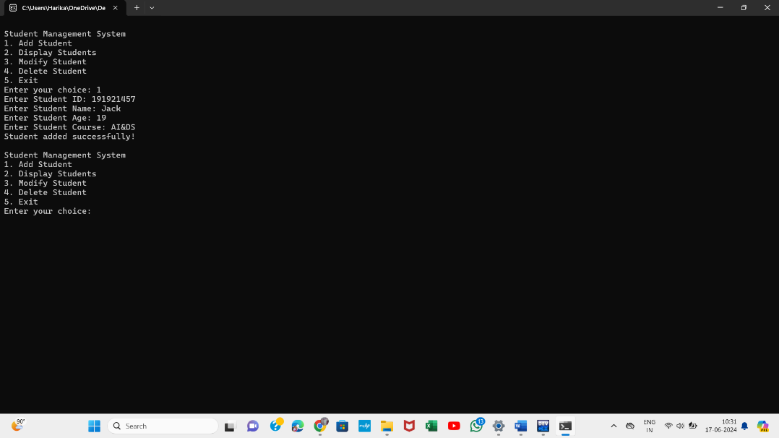

**Conclusion**

The Student Base Management System offers a practical solution for managing student records in small educational institutions. By providing a straightforward and efficient way to handle student data, it reduces the workload on administrative staff and minimizes errors associated with manual record-keeping. This system can be further enhanced with additional features like data validation, search functionality, and a graphical user interface.